**TASK-1**

**FILE HANDLING UTILITY**

**STEP 1:** Create a Java File

Create a file named FileOperations.java.

**STEP 2:** Java code

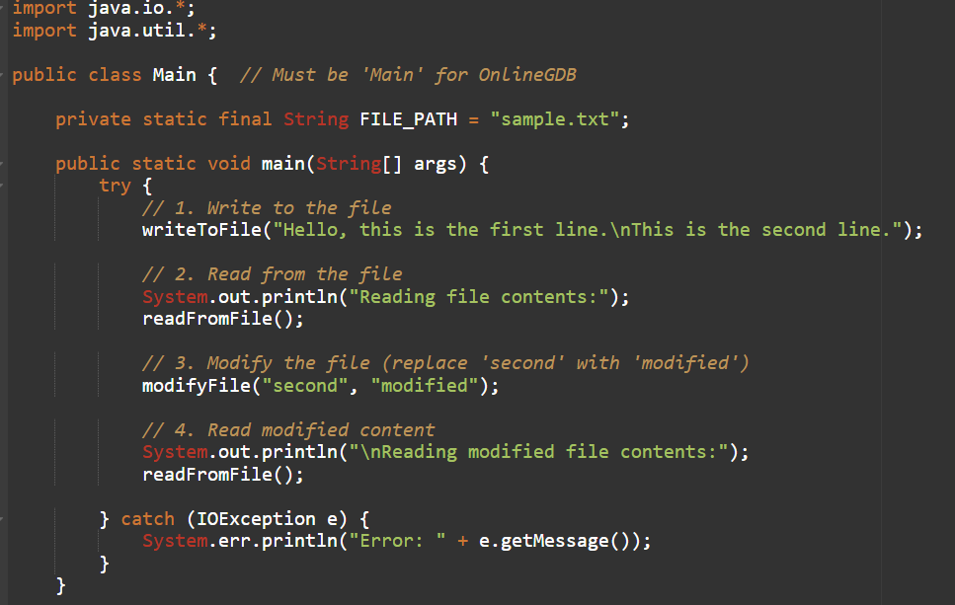

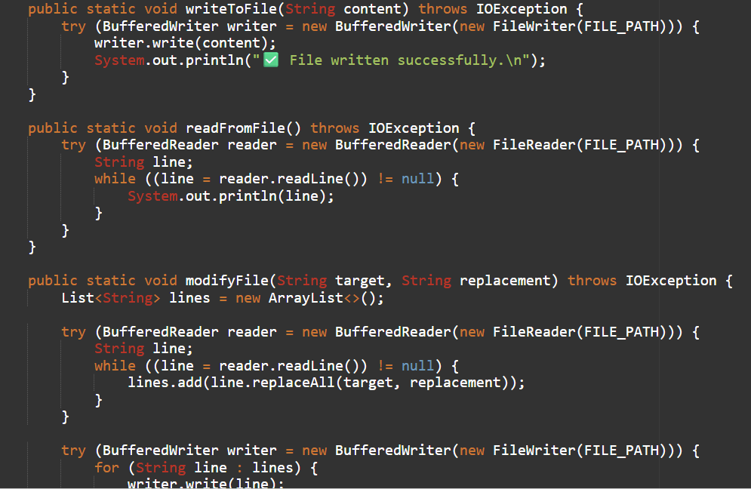

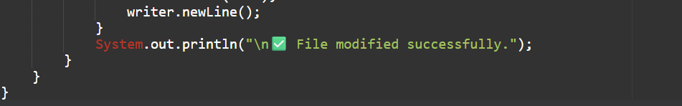

**STEP 3:** Output

